The Career Operating System is a structured framework for transforming daily work activity into long-term, evidence-based career intelligence. It unifies performance tracking, promotion readiness, and burnout analysis into a single, sustainable model for professional growth.

Scott Malin, Cybersecurity & Automation Architect

Career Operating System
Executive Workflow Guide
Contents
1. Overview 2
2. System Architecture 2
3. Engine 1 - Daily Activity Logger 3
4. Engine 2 - Aggregator / Markdown Builder 3
5. Engine 3 - Promotion Evaluator 3
6. Engine 4 - Burnout Deep Analyzer 4
7. Engine 5 - Performance Sustainability Integrator 4
8. Career File Maintenance & Structure Validator 4
9. Workflow Diagram 5
10. File Management Standards 5
11. Implementation Notes 5
12. Conclusion 5

1. Overview
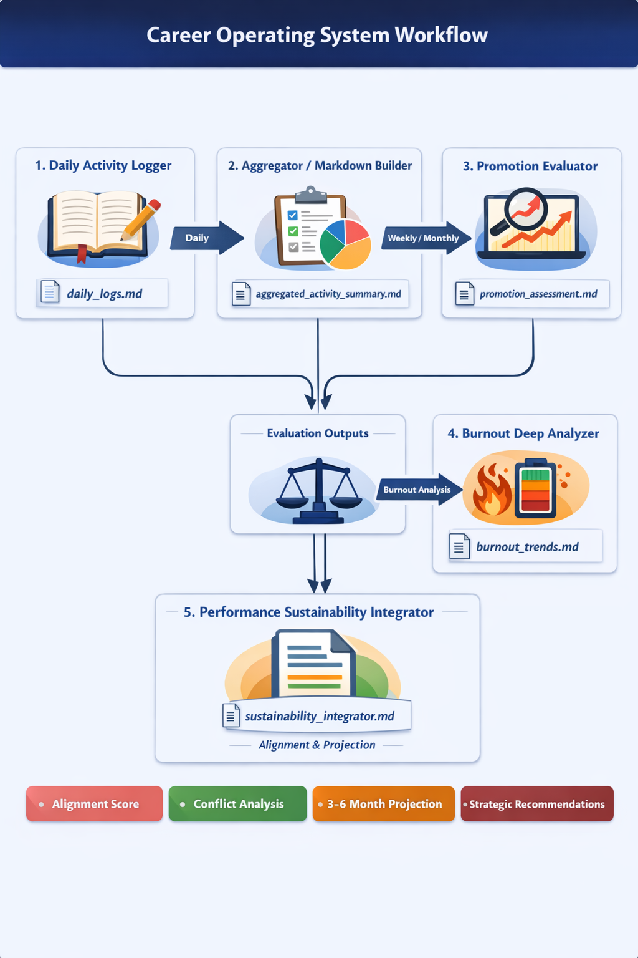
The Career Operating System is a structured, multi-engine framework designed to transform everyday work activity into long-term, evidence-based career intelligence. It provides a disciplined method for capturing daily effort, aggregating it into meaningful patterns, evaluating promotion readiness, assessing burnout risk, and integrating both into a unified sustainability model. This system is built for professionals who want to operate with clarity, intentionality, and strategic foresight. By maintaining a consistent record of work activity and feeding it through the system's engines, users gain a longitudinal view of their performance, growth trajectory, and overall career health.

2. System Architecture
The system is composed of five coordinated engines. Each engine produces a structured markdown file, enabling version control, offline review, and seamless integration with AI-assisted analysis. The engines operate independently but are designed to reinforce one another, creating a closed-loop feedback system that evolves with the user's career. The architecture emphasizes traceability, repeatability, sustainability, and governance.

3. Engine 1 - Daily Activity Logger
The Daily Activity Logger serves as the system's foundational intake mechanism. Users record free-form daily activities, capturing work performed, decisions made, challenges encountered, and outcomes achieved. The engine converts these entries into timestamped, append-only markdown records. This creates a reliable historical ledger of professional activity.
Primary Output: daily_logs.md

Key Features: Timestamped entries, outcome summaries, append-only structure, optional tagging.

4. Engine 2 - Aggregator / Markdown Builder
The Aggregator transforms raw daily logs into structured summaries. It collates entries on a weekly or monthly basis, identifies recurring themes, and organizes activity into categories such as accomplishments, challenges, deliverables, and strategic contributions. This engine introduces metadata, project tags, and contextual grouping.
Primary Output: aggregated_activity_summary.md

Key Features: Roll-ups, metadata enrichment, tagging, thematic grouping.

5. Engine 3 - Promotion Evaluator
The Promotion Evaluator analyzes the aggregated activity summary against the user's target role, industry expectations, and geographic market. It assesses readiness for advancement, identifies capability gaps, and highlights competitive strengths. It also generates resume-ready bullet points derived from logged activity.
Primary Output: promotion_assessment.md

Key Features: Readiness scoring, gap identification, competitiveness analysis, resume bullet generation.

6. Engine 4 - Burnout Deep Analyzer
The Burnout Deep Analyzer evaluates workload patterns, stress indicators, and sustainability metrics. Using the aggregated activity summary and optional self-assessment inputs, it identifies early signs of burnout, workload imbalance, or unsustainable performance trends.
Primary Output: burnout_trends.md

Key Features: Risk scoring, trend visualization, pattern detection, sustainability forecasting.

7. Engine 5 - Performance Sustainability Integrator
The Performance Sustainability Integrator merges insights from the Promotion Evaluator and Burnout Analyzer. Its purpose is to determine whether the user's current trajectory is both high-performing and sustainable. It identifies conflicts and provides strategic recommendations.
Primary Output: sustainability_integrator.md

Key Features: Alignment scoring, conflict detection, projections, recommendations.

8. Career File Maintenance & Structure Validator
The Career Operating System produces a series of markdown files that evolve over time. To keep these files consistent, well-structured, and ready for downstream analysis, this guide includes a dedicated File Maintenance & Structure Validator. This optional tool ensures that each file adheres to the system’s formatting, metadata, and structural standards.

The validator checks for required sections, correct header hierarchy, consistent formatting, and complete metadata across all four core files:

- daily_logs.md
- aggregated_activity_summary.md
- promotion_assessment.md
- burnout_trends.md

It can also correct minor issues, flag missing elements, and generate a brief maintenance report summarizing any updates made. This keeps the Career Operating System reliable, auditable, and aligned with governance-grade documentation practices.

Users can run the validator at any point to confirm that their files remain clean and structurally sound before feeding them into other engines or long-term storage.

9. Workflow Diagram
The following diagram illustrates the sequential flow of data from daily logging to sustainability integration, highlighting how each engine contributes to the overall architecture. It reinforces the system's core principle: daily actions compound into long-term strategic insight.
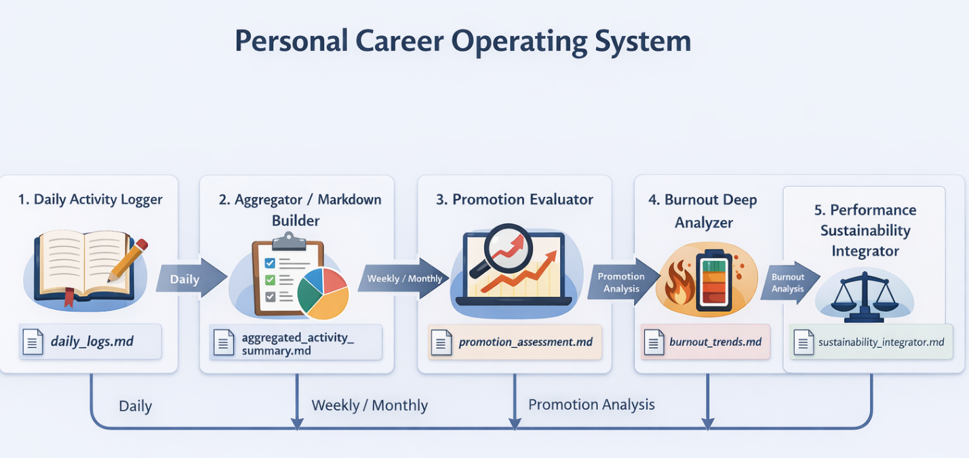

10. File Management Standards
Standards include consistency, versioning, append-only structure, backups, and integration across engines. These practices ensure durability, auditability, and maintainability.

11. Implementation Notes
The system is intentionally lightweight and becomes more powerful when paired with AI-assisted analysis. Markdown files, a folder structure, and consistent usage are sufficient.

12. Conclusion
The Career Operating System provides a disciplined, repeatable method for managing professional growth. It empowers professionals to operate with clarity, intention, and strategic foresight.

